COMP231-S62G1

Group 1

Food order app – User guide for Customers

Table of Contents

Purpose 2

Register an Account 3

Logging In 4

Browsing the Application 5

Browsing Restaurants and Menu Items 5

Going Back to the Restaurant List 6

Using the Shopping Cart 7

Adding an Item to the Cart 7

Viewing the Shopping Cart 8

Editing the Shopping Cart 9

Placing an Order 11

Going to the Order Confirmation Page 11

Consumer can receive order status notification 13

Viewing Account Balance 14

# Purpose

The main purpose of this application is to allow users to order food items from multiple restaurant vendors from their android device. The user does not have to wait in-line, and is notified when their order is ready for pick-up.

The core functionality of the application is as follows:

1. Identification: Logging in to the application
2. Browsing the application: browsing restaurants and its menus
3. Using the shopping cart: adding and managing items in the shopping cart
4. Placing an order: order confirmation and sending an order to the vendors
5. Receiving Updates: status updates and confirmation that the order is/has been processed

# Register an Account

A user is able to register an account on this application. To access the registration page, navigate to the login page, and click “Sign-up”. The registration page is also available at the top of the screen in the drop-down list. The registration page looks like the pages below:

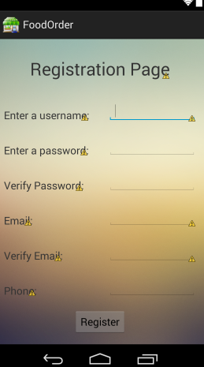

When the user clicks the “Register” button, the application will validate if all the fields are filled in correctly. If successful, the user will be redirected to the Login page.

# Logging In

The user is able to login to the application and view their account. If a user does not have an account, a there is an option to register. From there, account information such as username, phone number, email, and account balance information is stored. The following are some good to know features of login:

1. A user can login at any time. A login link is provided at the top of each page. Click “Login”.

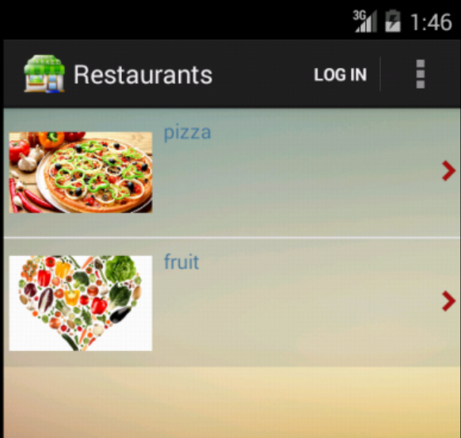

1. User enters username and password. Click the “Login” button.

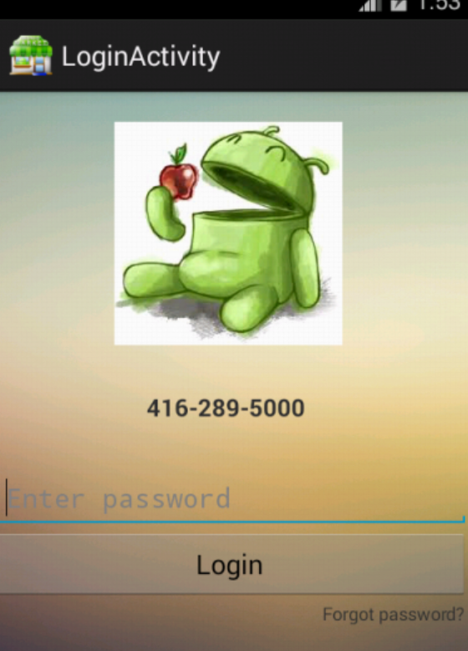

1. User is successfully logged in.

# Browsing the Application

Each user will have the ability to select the restaurant(s) of choice and select items to order from any restaurant. On each menu item, there is an option to select the details of the item and the quantity the user would like to purchase. The user also has the ability to select items from multiple restaurants in one session.

## Browsing Restaurants and Menu Items

This section outlines how to browse through the lists of items available. On the first page, each restaurant is listed. When a restaurant is clicked, a list of offered menu items are displayed.

1. Start the application.
2. Browse through the list of restaurants. If necessary, slide your finger vertically up or down on your android device to scroll through the list.

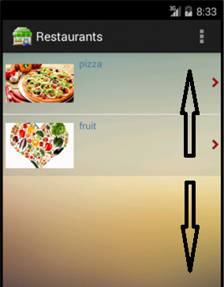

1. Select a restaurant by touching/selecting the item on the touchscreen of your device.

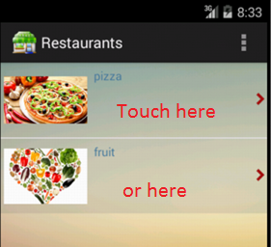

1. Browse through the list of menu items. If necessary, slide your finger vertically up or down on your device to scroll through the list.

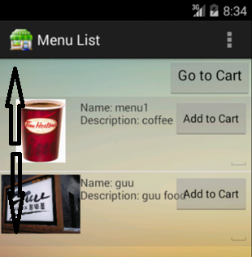

* You have successfully navigated to a list of menu items for a restaurant.

## Going Back to the Restaurant List

This section outlines how to navigate back to the list of restaurants.

1. Click the “back” arrow on your device. This takes you back to the list of restaurants.

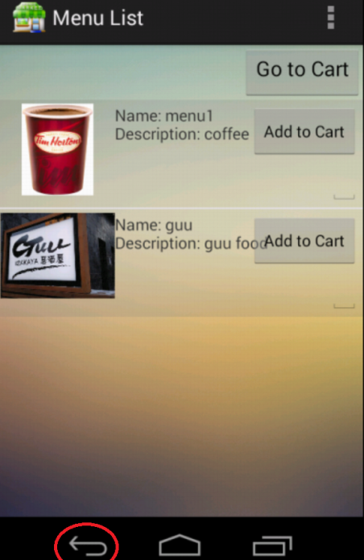

* You have successfully navigated back to the restaurant list.

# Using the Shopping Cart

The shopping cart will manage what the user wants to purchase. In addition to selecting the quantity of the order on the menu item, the user is able to update the quantities and remove items in the shopping cart.

## Adding an Item to the Cart

This section outlines how to add a menu item to the cart.

1. Navigate to the restaurant menu of choice. See steps from “Browsing the Application” for more information.

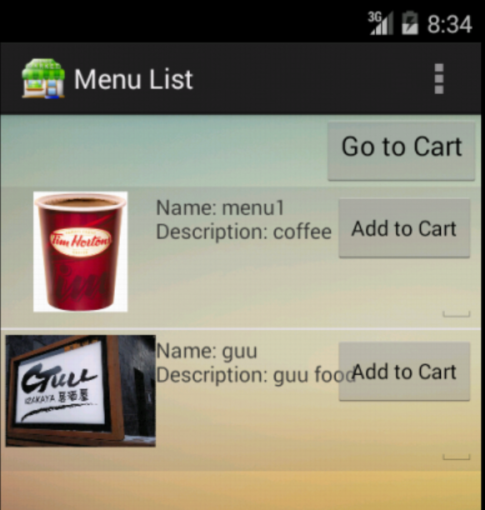

1. Enter the quantity by touching the text field on the device screen and typing in the number.

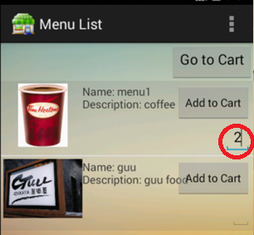

1. Select “Add to Cart” button.

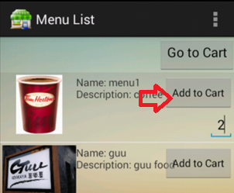

1. Repeat steps 1-3 for all other items.

* Items are successfully added to the shopping cart.

## Viewing the Shopping Cart

This section outlines how to go to the Shopping Cart page.

1. Navigate to the restaurant menu of choice. See steps from “Browsing the Application” section for more information.



1. Select “Go to Cart”.

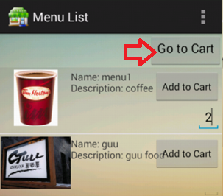

1. The items that were added to the cart are displayed on this page.

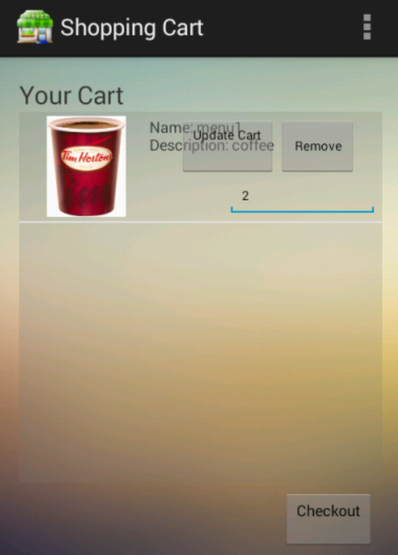

* Successfully viewed the shopping cart.

## Editing the Shopping Cart

This section outlines how to edit the items added to the Shopping Cart. This includes adding and updating the items in the Shopping Cart.

1. Navigate to the Shopping Cart. See steps from “Viewing the Shopping Cart” section for more information.

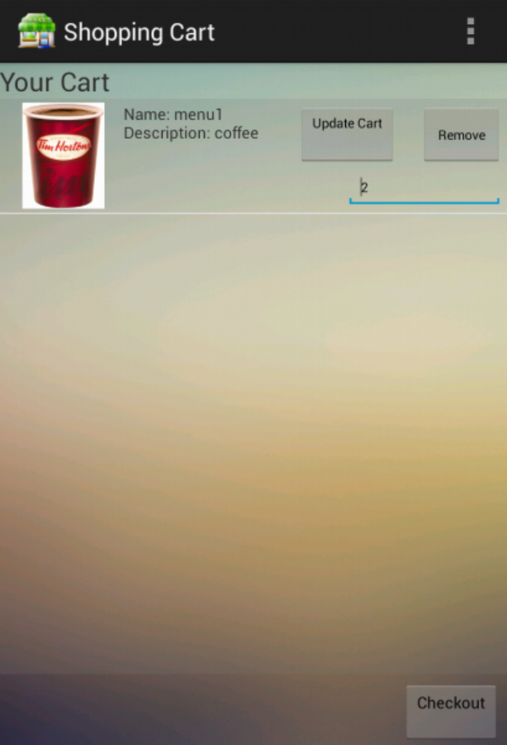

1. The following options are available:
   * Remove an item: Select “Remove” on the item of choice. If more than one item needs to be removed, select “Remove” as many times as needed.

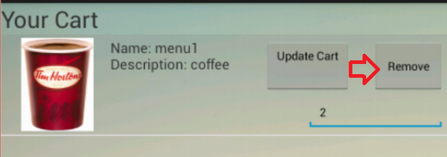

* + Update quantity: Touch the text field on the device screen where the quantity is displayed and retype in the correct number. Select the “Update” button.

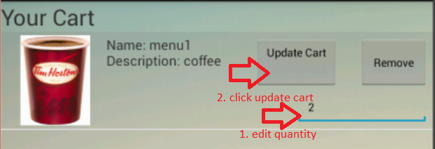

* Successfully remove an item or update the quantity of an item in the Shopping Cart.

# Placing an Order

The order page will allow a user to confirm what items are being ordered. An order placed is paid for using a prepaid card that was purchased beforehand.

## Going to the Order Confirmation Page

This section outlines how to initiate the process to place an order.

1. Navigate to the Shopping Cart. See steps from “Viewing the Shopping Cart” section for more information.



1. Select “Checkout”.

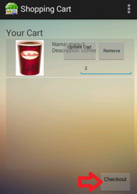

1. The Order Confirmation Page is displayed.

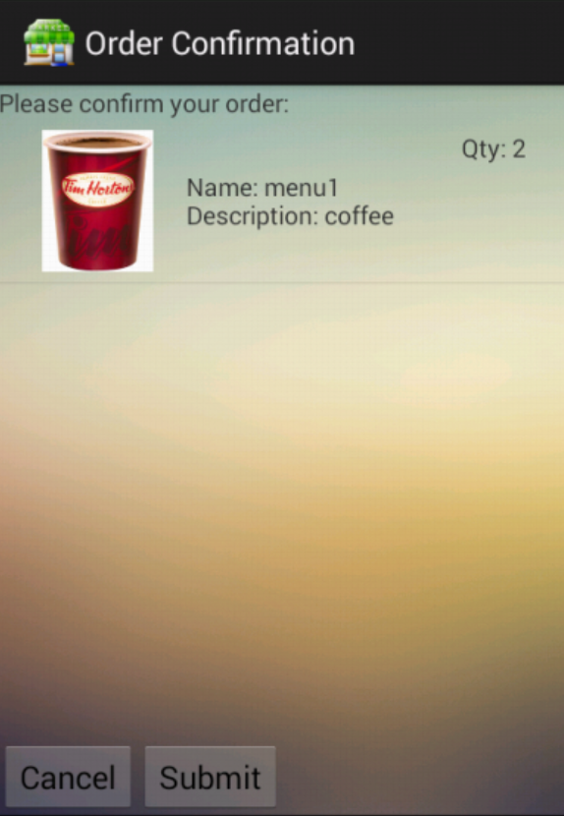

* Successfully initiate an the order placing process

# Consumer can receive order status notification

Your order is sent electronically to the restaurant the instant when you click “Submit”. Your order will be sent automatically at the restaurant application with all details information. The restaurant then determines to accept or reject your order. If the order is accepted, the restaurant will send you the notification. When the order is completed, the restaurant will send you the completed order and notice you to pick up. If the order is rejected, the restaurant also will send you the notification with the reason for the rejection. The food order application will check the order status for each 30 seconds. When order status is updated, the notification bar will be launched automatically as below picture.

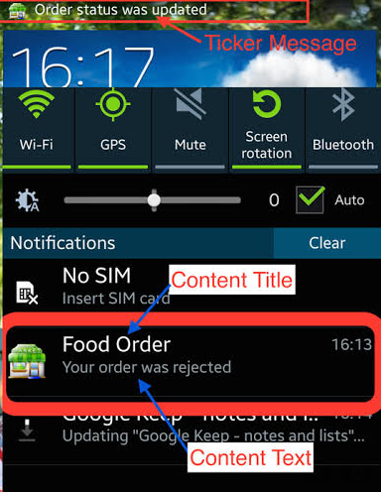

When you click the notification bar, you can view the order details as below picture.

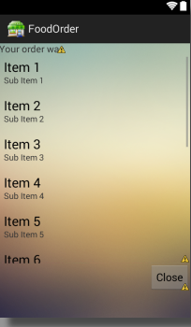

TBD

# Viewing Account Balance

A user can view account balances at any time. To do this, the user navigates to the Add Balance Activity to see the active balance on the account.

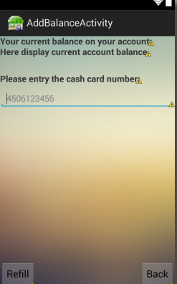

The user can also refill the balance by entering the cash card number and clicking “Refill”.

# Edit User Information

A user can edit their user information when he/she is logged in. Some fields that can be edited are: Phone # and Email. Username is also displayed for reference.

To navigate to the page below, go to the “User Information” page and click “Edit User Info”.

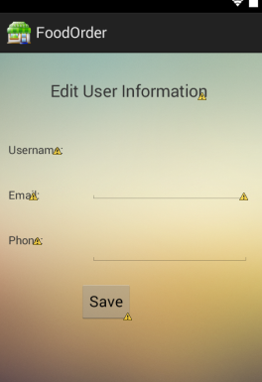

Once the user clicks save, the information will be updated.